Developmental Project Application Review
Thank you for your time and expertise in reviewing this application. Please note:
- Comments will be shared with the applicant. Please include strengths and weaknesses. Any score below 3 must include comment on weaknesses.
- For questions 1–5 with a numeric score, please use the NIH scoring system. A score of 1–3 should be a proposal of high importance to the field with no more than some minor weaknesses, while a 5 is a good application:
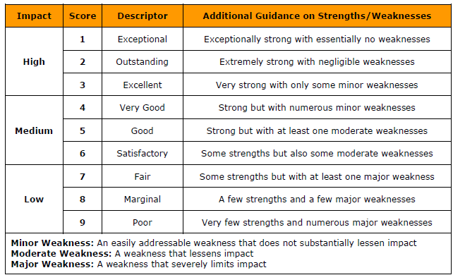
- Significance. Does the study address an important question related to ADRD that is likely to have a meaningful impact on the field and eventually for patients and families?
Score (1–9)
Comments

- Approach. Are the study design and methods appropriate to address the proposed question? Are they rigorous and statistically sound? Are all necessary controls included?
Score (1–9)
Comments
- Feasibility. Is the investigator team well suited to do this work? Is the scope of work reasonable to accomplish in the 1-2 year award period? Is all necessary equipment available? Is the project ready to launch if funded?
Score (1–9)
Comments

- Future Potential. Is this project likely to lead to future extramural funding?
Score (1–9)
Comments

- Overall Impact. Considering all of the above, how do weigh the potential impact of this proposal?
Score (1–9)
Comments

- Additional, non-scored criteria:
  - Budget. Please comment on any concerns.
Comments

  - ADRC Connection. Please comment on the degree to which the proposal relates to the ADRC theme of Deep South disparities in dementia and/or uses ADRC resources (participants, data, biospecimens). Note: such a connection is desirable but not mandatory, especially for preclinical studies, e.g. using animal models.
Comments

